**MongoDB -Aggregation Exercises**

Import the zips.json file into your MongoDB. Database name is "population" and

collection name is "zipcodes".

mongoimport --db population --collection zipcodes --file zips.json

**Atlanta Population**

1. use db.zipcodes.find() to filter results to only the results where city is ATLANTA

and state is GA.

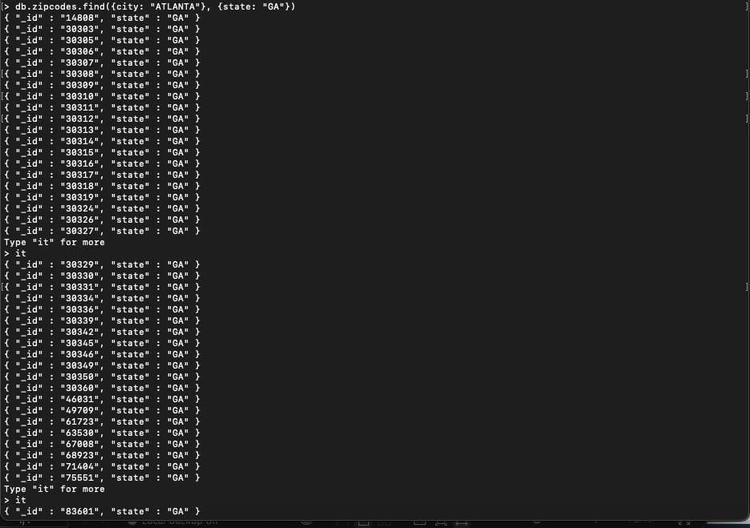

2. use db.zipcodes.aggregate with $match to do the same as above.

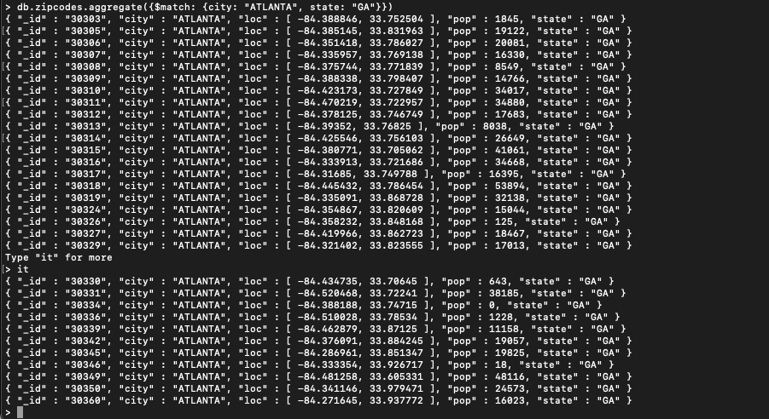

3. use $group to count the number of zip codes in Atlanta.

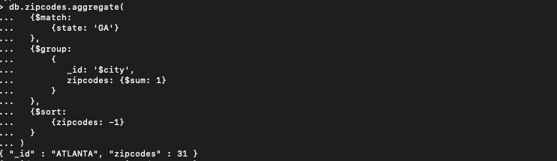

4. use $group to find the total population in Atlanta.

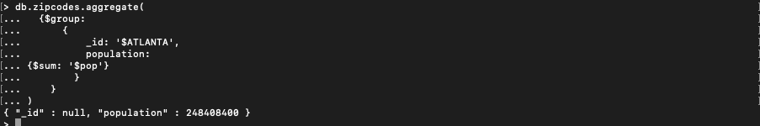

**Populations By State**

1. use aggregate to calculate the total population for each state

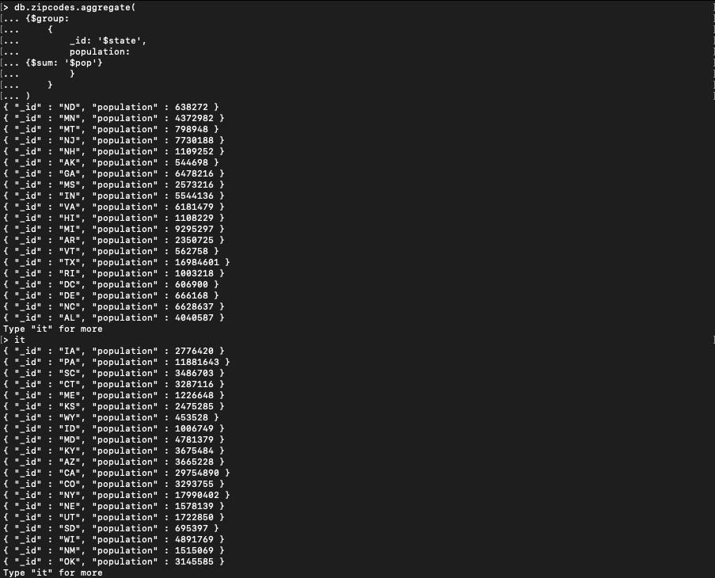

1. sort the results by population, highest first

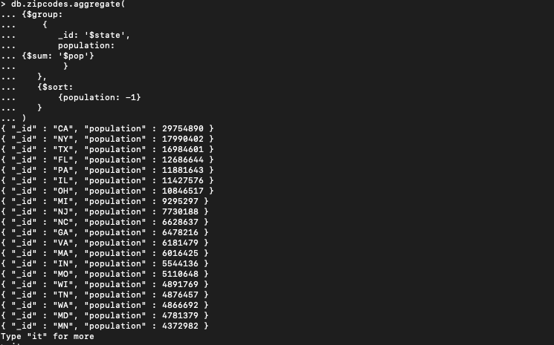

3. limit the results to just the first 3 results. What are the top 3 states in

Populations?

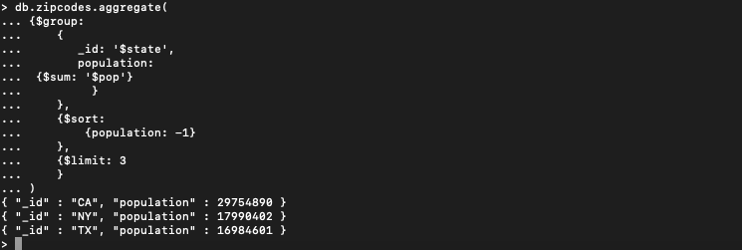

**Populations by City**

1. use aggregate to calculate the total population for each city (you have to use

city/state combination). You can use a combination for the _id of the $group: {

city: '$city', state: '$state' }

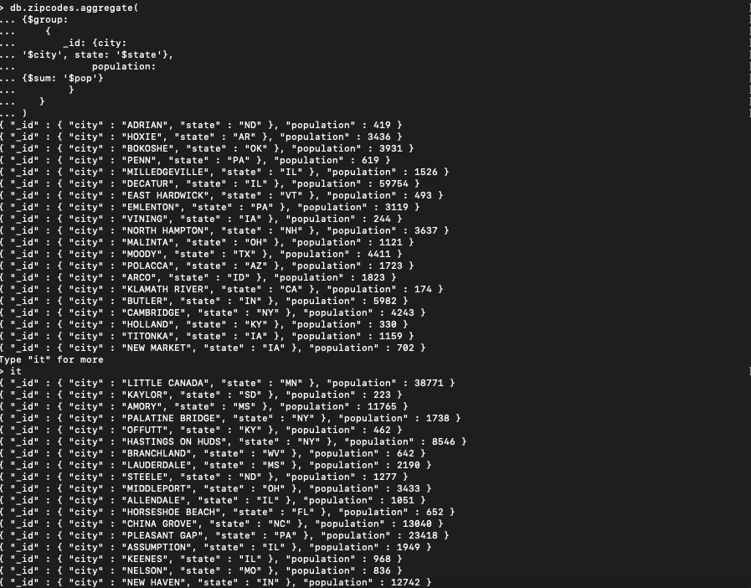

2. sort the results by population, highest first

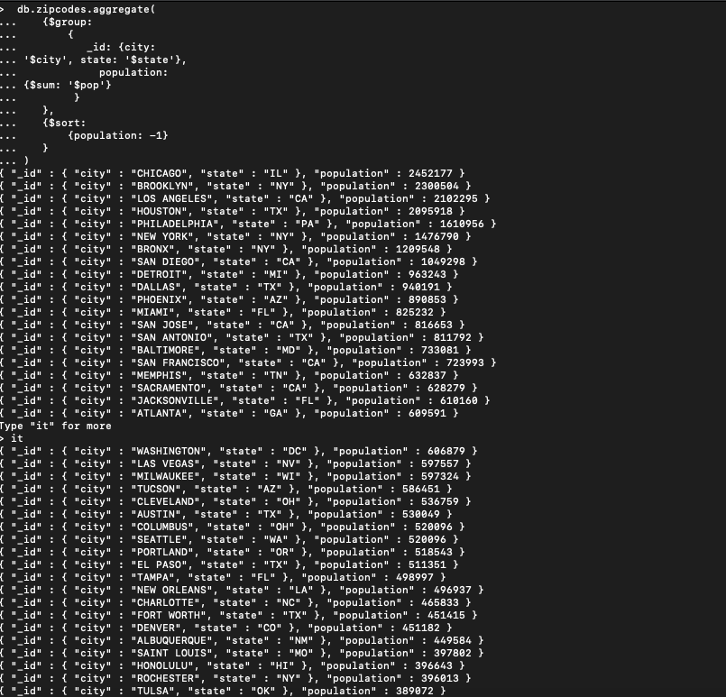

3. limit the results to just the first 3 results. What are the top 3 cities in

population?

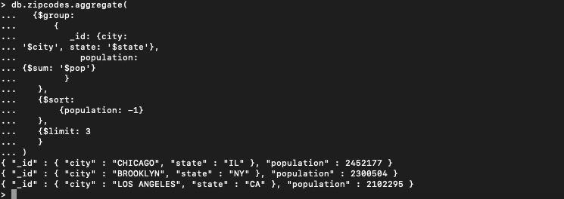

4. What are the top 3 cities in population in Texas?

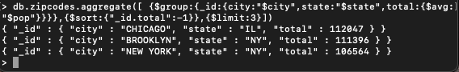

**Bonus**

1. Write a query to get the average city population for each state.

2. What are the top 3 states in terms of average city population?

